
DON’T BE FOOLED - ENROLL FOR CAMP- EARLY RATES TILL APRIL 30th
NO FOOLING! IT REALLY IS  &

The weather hasn’t been great but we’re preparing camp for June 25th. We can’t wait to see all of our camp friends and begin the 2018 summer season.

NEW THIS SUMMER –

PADDLE-ZLAM – TRICROSSE – BOX HOCKEY & OTHER SURPRISES

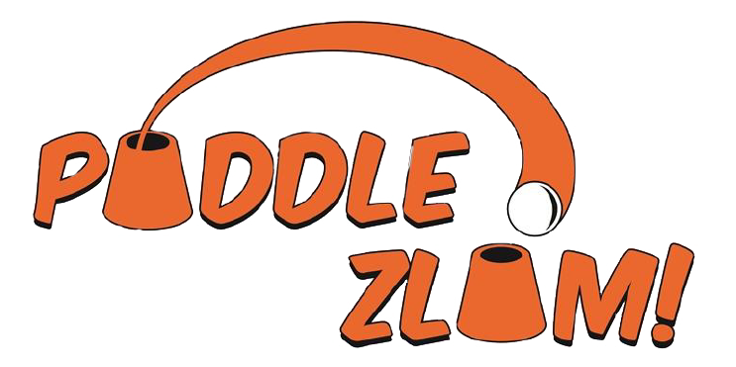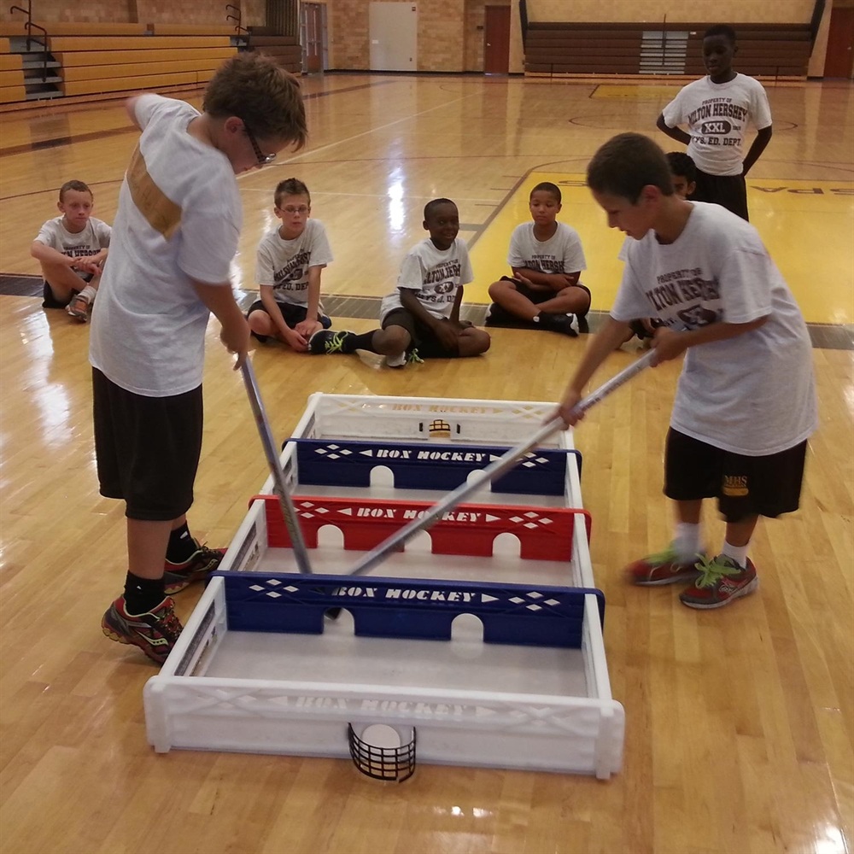

REMEMBER - 9:15am LINE UP FOR JR. & SR. CAMP

IS ONLY 2,049 HOURS & 15 MINUTES AWAY

APRIL BIRTHDAYS
4/1 VIVIAN FRITZ, ZACHARY LYON, SAM DEAN 4/2 MAEVE BOURGUIGNON, JUSTIN DEFABRITIS 4/3 JACK CORDERO, MILANA TORRE 4/4 ISABELLA TRACY 4/5 DYLAN ROY, ASIA TRENT 4/6 PEYTON MC GRADE, ROBERT SHERTER, BRIELLE MERLO, DAVID DI LIBERTO, MYA MANZELLA, CALEB WHITE, TATIANA CORONEL 4/7 JOAQUIN CHICON, BRAYDEN MANION, ENIYAH EASON 4/8 FRANK GRAUPE, BIANCA MC CARTHY, ELIZABETH COMBS 4/9 DARIEN FRANCISQUINI 4/10 ETHAN VERMAAT 4/11 MIA GHOLSON, ZACHARY MARCO 4/12 JAMES MASSARO 4/13 LUKE LOEWE, GIANA PORTER 4/14 CONNOR SCHULMAN, VICTORIA DE ROSA 4/15 JOSHUA ARCHIBALD 4/16 EMMA VALENTINE 4/17 GIOVANNI BORELLI, LYDIA DEPTUCH, GABRIEL PEREZ, BEN SCHUIERER 4/18 DANIEL BELYANSKY, EMILY CRAMER 4/19 GRACE CONWAY, CAELY GABRIELLI, GIANNA BORELLI, CALEB MOYSON 4/20 JOSEPH SIRICO 4/21 LYDIA COLON, ARINA SMIRNOVA 4/22 OLIVIA BAUMANN, MICHAEL EINHORN, JOHN BERRY, DANICA FORD 4/23 CHRISTIAN MC CLAIN, AVERY DUNTON 4/24 AARON CORPAS 4/25 ASHLYN MANION, JOSEPH BELLONE, NATHAN KRAKAUR, BRIANNA MC LOUGHLIN, DENNIS HAYES 4/27 ALEXANDRIA BECKER, JAMES CANGELOSI, AVA CAHALAN, SEAN PANKER 4/28 LOGAN BUROKER 4/29 RYAN BENDER, MIKEY MANZELLA 4/30 ZACHARY PAPADAKIS

(OVER)

WE WELCOME THE FOLLOWING CAMPERS TO THE 2018 SUMMER SEASON:
IF YOUR NAME ISN’T HERE, WHAT ARE YOU WAITING FOR?
N: ALINA BECK, GRACE CONWAY, MAKAI FLORES, CASSANDRA HOGAN, THEABELLA LABRUZZO, AARON LOUGH, CARTER PERKINS, OWEN TRUSNOVEC GK: SOPHIA BERNARD, MIA BUONANOTTE, JESSICA CURLEY, ALEXA FERRO G1: PAIGE BRADLEY, GIA CHICON, MADISON DIAMOND, LEAH EPSHTEYN, MILAH FLORES, EMALEE GABRIELLI, OLIVIA GUGLIELMO, BRIELLA KOMOSINSKI, REBECCA OLSEN G2: ADDY BECK, ELLA BELLONE, GIULIANA EDELMAN, MADISON EISNER, SAMANTHA FITCH, OLIVIA LA PORT, MIA LOEWE, CAROLINE MC GRADE, DANIELLA NUNEZ, JULIA TAPHOUSE, JAELYN TRUSNOVEC, AMANDA VACCARO G3: KARISA DE BLANCO, JULIANNA MAGLIULO, MADELINE MAYER, MADELINE MC LAUGHLIN, BRIELLE MERLO, KATE POLAK, ARIEL RAFUSE G4: SARAH BENDER, CHARLOTTE COHEN, SAMANTHA EPSHTEYN, AVIANA HIGUEROS, MADISON MAKOWSKI, ABIGAIL PLATTI, AUBREE POACH, ASHLEY RUSCH G5: EMILY BECHTOLD, DANICA FORD, AUDREY FREY, RYAN NEWBERGER, ELENA PALERMO, DANICA RYMER, MEGAN SCULLY, MADELYN SCHMIDT, CHLOE SOMERLAD, ISABELLA VOLINO G6: DESTINY AIELLO, EMILY BELYANSKY, ISABELLA BORDERS, ADDISON CHASAN, CAELY GABRIELLI, ALESSIA HIGUEROS, DANIELLE O’SULLIVAN, HANNAH RAFUSE BK: ZANE DAVIS, LINCOLN DONATO, RYAN DOUGHERTY, CADYN DE BLANCO, BENJAMIN HOGAN, LARS KING, LUCAS LA ROSA, SPENCER LIEB, ANDREW MANNHEIMER, GIOVANNI MORALES, PHILIP TANCORA B1: FRANK COSTA, JAKE DENGEL, JORDAN FORREST, JOHNNY LICATA, JACOB MCVEIGH, CARTER MERLO, JOSEPH RIENZI, BREWER SPINELLA, ANDREW WELDON B2: GRANT BARRY, JACOB BAUMANN, RYAN BECK, COLBY BRAUN, JACOB BUONANOTTE, BRENTT COHEN, FRANK GRAUPE, JAMES HUEMMER, RYAN KHAN, AIDAN MACA, CALEB MOYSON, MARCUS NEWBERGER, MASON PLATTI, LEVI RUBENSTEIN, JAMESON SCHAARSCHMIDT, ALEX VIOLA B3: GEORGE AGAGNINA, CHASE BRADLEY, JAX CHASAN, JOSEPH CURLEY, LUKE CURTO, JACOB LINCOLN, MICHAEL LOUGH, JAYDEN MINTER, AIDEN SCHOLL B4: JOSH BENDER, JOEY BELLONE, TYLER DRACHTMAN, GAVIN EHLICH, JAIDEN FLORES, ANGUS FYFE, JAIDEN GUGLIELMO, KEITH HARRIS, DANIEL IANNACCONE, VICTOR PERKINS, LEONARD RIENZI, HOLDEN SPINELLA, JAMES TAPHOUSE B5: ANTHONY ASQUINO, JOAQUIN CHICON, ASHTON KLUGEWICZ, JACK POLAK, NOAH RUBENSTEIN, LIAM STEHL, LIAM ZENKER B6: SEAN BECKER, CHRISTIAN BROSZEIT, LUCAS COLON, TYLER DEFABRITIS, AARON DIAMOND, AIDAN ECK, CONNOR HENZEL, BENJAMIN JONES, LUKE LOEWE, PEYTON MC GRADE, TREVOR RODECKER PT: DEREK AIELLO, MICHAEL CAMERON, CHAYSE CARPINO, KATELYN COOPER, AUTUMN DANZIGER, ADDISON FATTIZZO, ZOE FYFE, NAOMI HARRIS, MATTEO HIGUEROS, ALYSSA LODS, KAYLYNNE MC CARTHY, RENEE ORTIZ, ALEXANDER PAULETTI, GABRIEL PEREZ, CASSANDRA PFAUTSCH, CHARLOTTE SAVELLI, KAELYN SCHMIDT, MEGAN SCOVANNI, SCARLETT STEVENSON, HANIIF SUMMERS, LEAH TUMOLO, JACK WALSH JT: FRANKIE ANDERSEN, THOMAS ANZALONE, OLIVIA BAUMANN, KYLIE BECKER, DANIEL BELYANSKY, RYAN BENDER, NOLAN BORDERS, LYDIA COLON, EVE DANZIGER, JUSTIN DE FABRITIS, MATTEO DI GIROLAMO, JUSTIN DRACHTMAN, HANNAH EHLICH, J.ALEXANDER GARCIA, JAKE GREENBAUM, ALANA GRUNDAS, ANDREW GRUNDAS, JOSHUA KOENKE, BRANDON MAKOWSKI, JAMES MASSARO, DANIEL MATTHEWS, LOGAN O’SULLIVAN, EMMA PARENTE, ARIANNA POLYCHRONAKOS, EVAN RILEY, AUSTIN SULLIVAN CIT: KAITLYN BECKER, JACK BIRK, THOMAS ENGEL, AUTUMN HERKOMMER, SARAH KRUZYNSKI, MADELINE LEATHERS, MARY MADIGAN, MEKAYLA MANWARING, ROBERT MEIER, GRACE POLAK, GIANA PORTER, JORDYN RODECKER, KATHLEEN SEDA, DANIELLE WALSH


